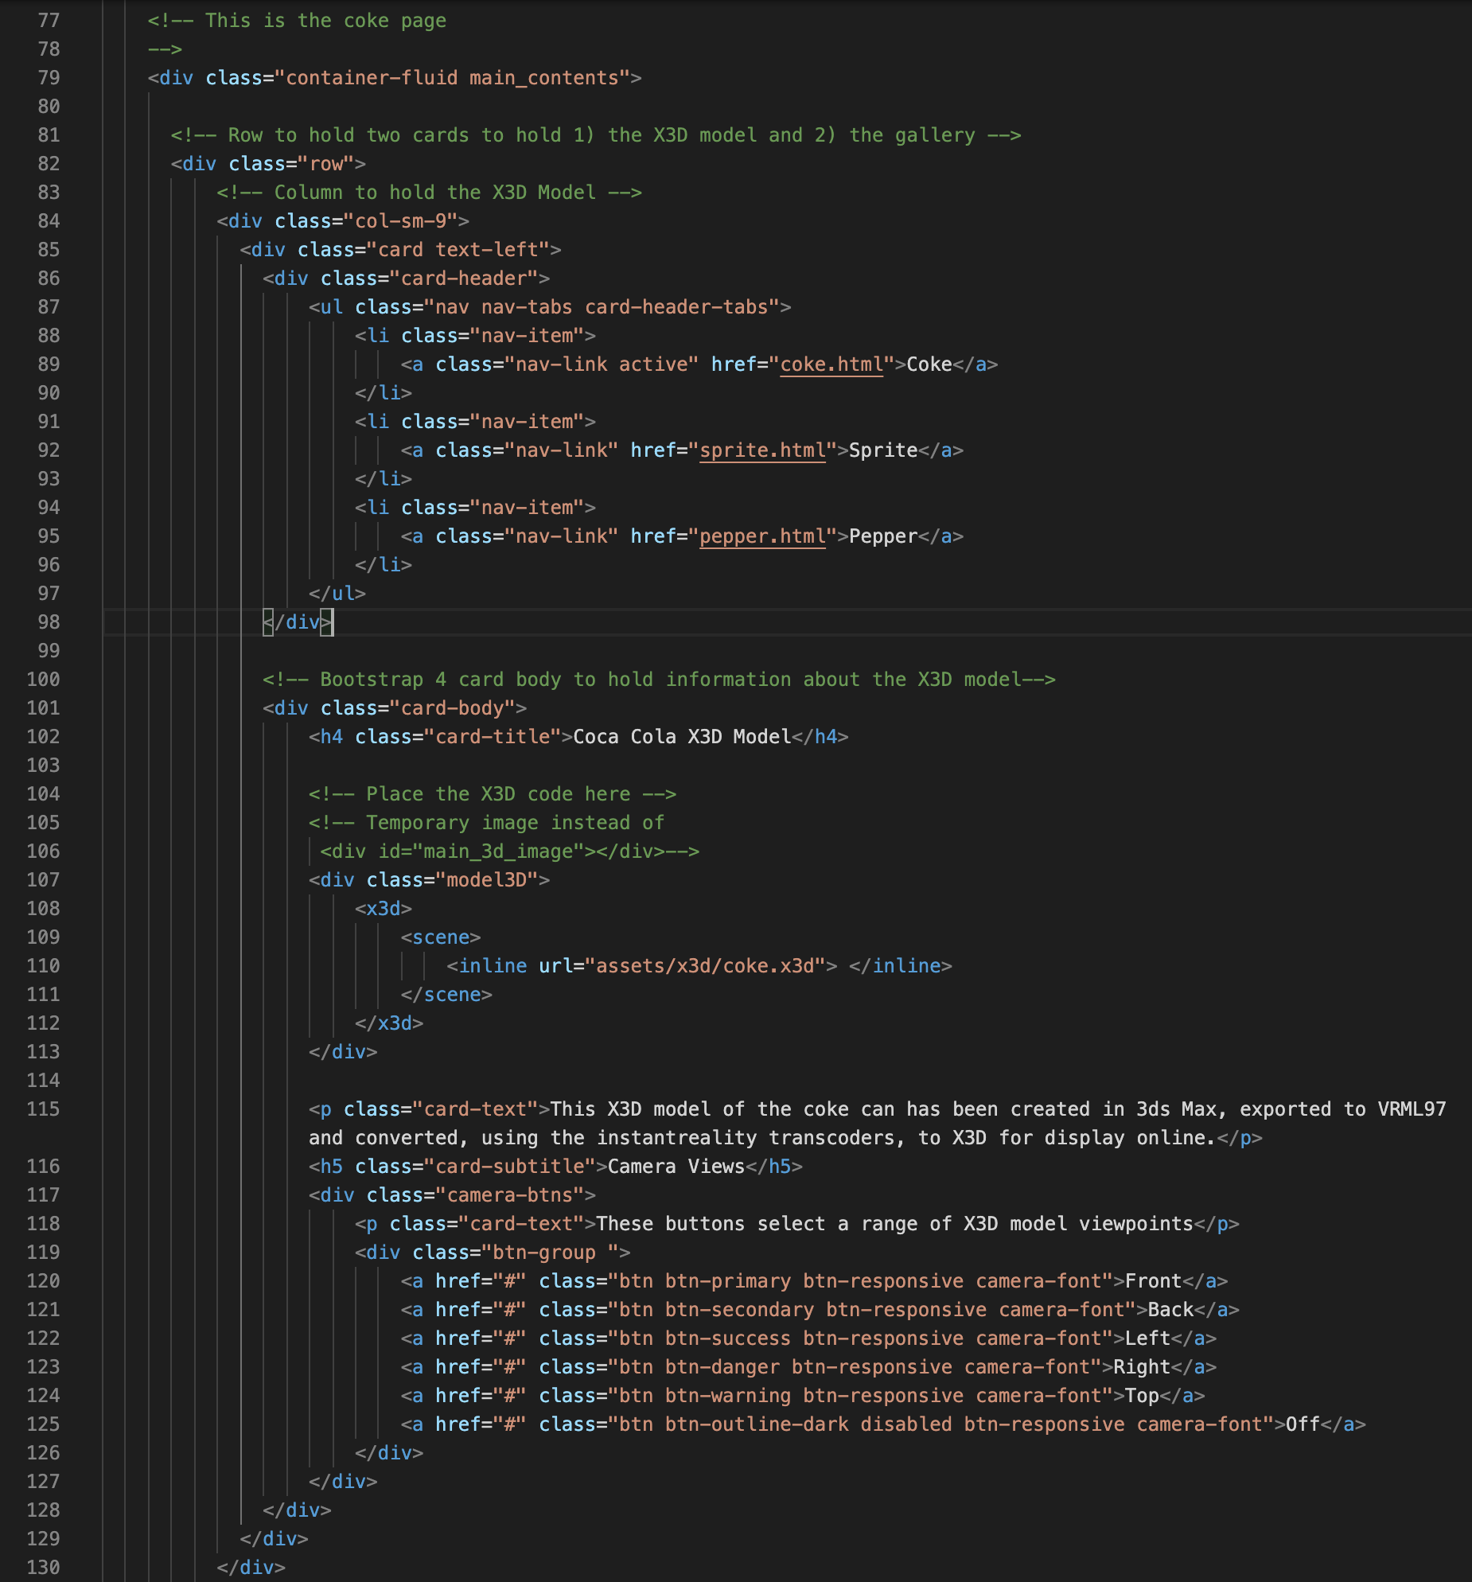

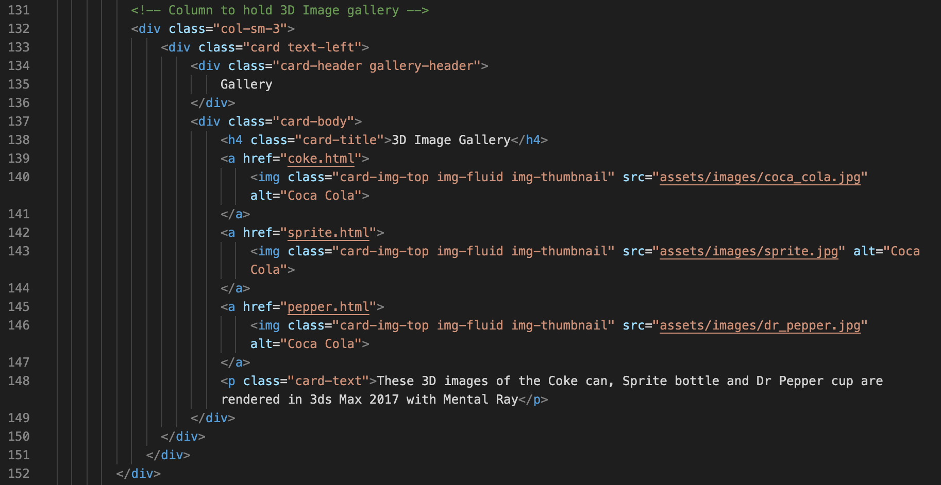

|  |
| --- |
|  |
| CSS libraries — note custom.css is last so that it overrides any bootstrap or x3dom CSS as necessary |
|  |
| Logo and navigation menu |
|  |
| Main contents for the coke page — the X3D model in a card with navigation tabs and buttons |
|  |
| Main contents for the coke page — the gallery 3D images in a card |
|  |
| Main contents for the coke page — the coke description in a card |
|  |
| Footer and JavaScript libraries — javaScript is usually put at the end to execute after the DOM is loaded |